Electromagnet Safety Report

Electromagnetic Holding Torque and Deflection Testing

Date: | 07/09/2026
Student & SU nr: | Lena Matota, 24989142
Student contact nr: | +27 71 569 2349
Supervisor: | Kristiaan Schreve
Lab engineer: | Kevin Neaves
Head of safety: | Mr Cobus Zietsman

Emergency Contacts:

Contact: | Room nr. | Work nr. | Cell nr.
Kevin Neaves | M3001 | - | -
Mr C. Zietsman | M212 | 021 808 4275 | -
Campus Security | - | 021 808 2333 | WhatsApp:  082 808 233
Fire Brigade | - | 021 808 8888 | -
Ambulance | - | 021 883 3444 | -

Signatures:

Student:
(Lena Matota)
Supervisor:  (Kristiaan Schreve) | 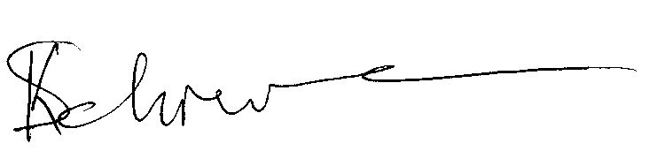
Lab Engineer:
(Kevin Neaves)
Head of Safety:
(C Zietsman)

Pressure vessels or pipes (check relevant box):
☒ No pressure vessels or pipes with pressure in excess of 50kPa are involved in this project.
☐ Pressure vessels or pipes in excess of 50kPa are involved – additional signature and report required (refer to Safety Report Guidelines on SUNLearn).

Hot work / working at heights / confined entry / excavation (check relevant box):
☒ No hot work / working heights / confined entry / excavation work involved in this project.
☐ Hot work / working heights / confined entry / excavation work (underline relevant work type(s)) involved in this project – additional signature and report required (refer to Safety Report Guidelines on SUNLearn).
Overview of Testing

Type of test and standard (if applicable):

Test type | Strain gauge and deflection measurement of an electromagnet
Standard(s) | Internal component validation; TANDM Strain Gauge Installation Guide

Equipment to be used:

Equipment type | Make & model | Measurement range (if applicable) | Resolution (if applicable)
Fabricated electromagnet | Custom | Max $12{ V}_{DC}$, 6$A$ | -
Emergency Stop Button | NC Latching Push Button | Max 24${ V}_{DC}$, $10 A$  Max $24$ | -
Microcontroller | STM32 Nucleo F114RE | $3-3.6{ V}_{DC}$, $0.8 A$ | -
MOSFET | Infineon IRF640NPBF | ${20 V}_{DC}$, $18 A$ | -
Voltage Buck Converter | XL7015 Step-Down Buck Regulator | $V_{in}$: $5-80 V$, $V_{out}$: $5-20 V$ @ $0.8 A$ | -
Flyback Diode | STMicroelectronics STPS20H100CT | Max 100${ V}_{DC}$, 2$0 A$ | -
Gate Resistor | - | $330 Ω$ | -
Pull-down Resistor | - | $10 kΩ$ | -
Data acquisition system | HBM QuantumX (801433534) | $$± 100 mV/V$$ | -
DC power supply | Manson HCS-3202 | $1-36 V_{DC}$, $10 A$
Multimeter | Keysight U3402A | - | -
Strain gauges | Foil Quarter-bridge | - | -
Soldering Iron | Adjustable temp LCD kit | - | -
Sandpaper | 220-grit | - | -

Detailed Experimental Procedure

Introduction
The purpose of this test is to verify the functionality of a custom-fabricated electromagnetic brake joint design by testing its holding torque and the deflection in the pressure tabs of the electromagnetic brake. Strain gauges will be mounted on the pressure platform where strain is the highest to calculate the holding torque. Deflection will also be measured to verify that the brake functions correctly with the designed $3 mm$ air gap between the brake disc and friction plate.

PPE Required
- Safety glasses
- Protective gloves

Preparation and Strain Gauge Installation

Solenoid Preparation
- Apply a thin layer of high-temperature Kapton tape directly over the bare metal core to insulate it.
- Verify that the copper wire is free of kinks or breaks.
- Carefully wind the copper wire directly onto the insulated core, ensuring tight, uniform layers.
- Strip the enamel coating from the ends of the wire leads using fine sandpaper and insert the completed coils into the custom electromagnet housing.

Setup Procedure

- Assemble the custom switching circuit, wiring the normally closed (NC) emergency stop button in series with the DC power supply.
- Connect the switching circuit to the fabricated electromagnet.
- Secure the electromagnet using non-magnetic metal blocks clamped against the workstation surface to prevent the rolling and movement during testing.

Safety Checks

- Ensure all safety warnings, as shown in Figure 2, are clearly visible.
- Make sure the blocks are properly secured before placing the electromagnet to prevent accidental slipping.
- Ensure all switching circuit connections are insulated before connecting the switching circuit to the power supply.
- Verify the functionality of the emergency stop button by engaging it before running full power through the electromagnet.
- Check for any nearby objects that may be affected by the electromagnetic field before engaging the electromagnet at full power.

Connections and Loading

- Clean the pressure platform surface thoroughly using RMS 1 spray ad cleaning pads to remove grease or oil prior to sanding.
- Manually sand the $50×50 mm$ installation area using the 220-grit sandpaper in a circular motion to remove surface flaws and create appropriate roughness, taking care not to alter the component’s geometry.
- Clean the area again with RMS 1, wiping in only one direction until the cleaning pad comes off clean.
- Mark the strain gauge position using a pencil. Do not use scribes to prevent stress concentrations.
- Apply Z70 adhesive and spread it with a Teflon strip, then place strain gauge and apply constant pressure with a thumb for 1 minute.
- Clean the solder pads with a fibre tip pen, apply flux using a flux pen, and solder the rainbow cable to the strain gauge using the adjustable temperature soldering iron.
- Test the connection with the Keysight U3402A, multimeter to ensure proper resistance and no continuity between the solder pads and the material surface.
- Apply protective covering over the soldering connections.
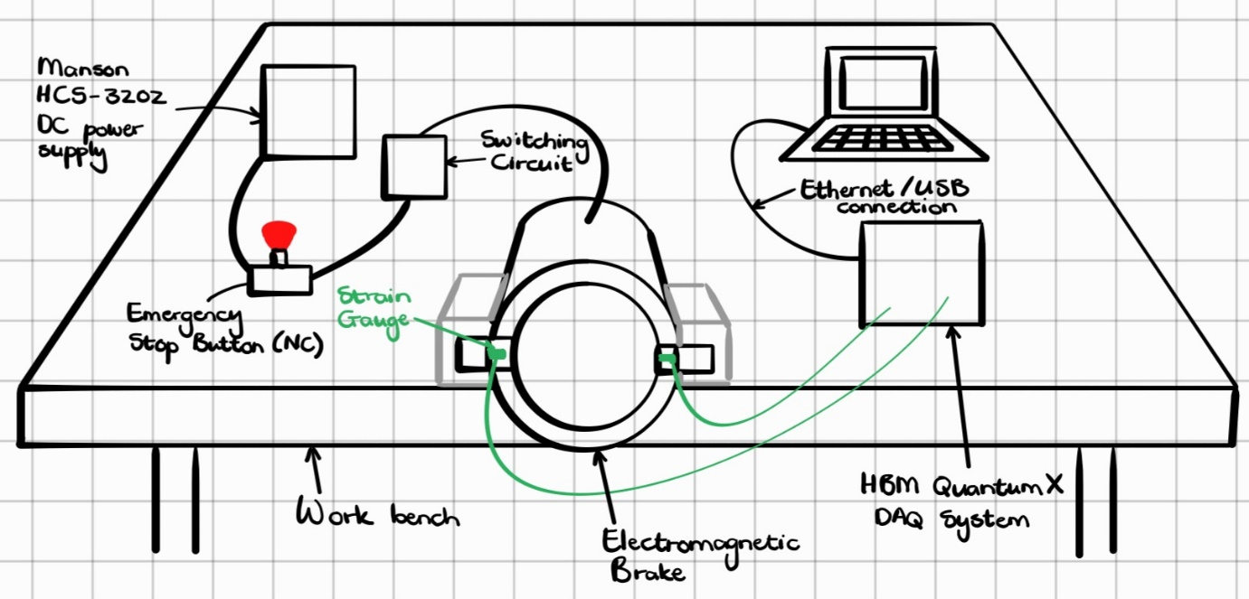
Figure 1: Experimental Setup
This set up must be inspected by the study supervisor and lab engineer before commencing any work. The electrical circuit may not be activated before this inspection is successfully completed. The signatures below will confirm that the set up is ready for operation.
Signatures:

Supervisor:
(Kristiaan Schreve)
Lab Engineer:
(Kevin Neaves)
Head of Safety:
(C Zietsman)

Testing Procedure

- Assemble the electromagnet.
- Connect the installed strain gauges to the HBM QuantumX DAQ.
- Activate the switching circuit to engage the electromagnet.
- Record the strain measurements from the pressure platform to calculate the holding torque.
- Measure and record the deflection of the pressure platform while the electromagnet is engaged.
- Deactivate the switching circuit and verify the components return to their resting state.

Data Handling

- Save the recorded strain and deflection data from the HBM QuantumX to a designated folder using a consistent naming convention (e.g. “Sample#_Date_Test#”).
- Transfer the data to an external drive or cloud storage before powering down.

Shut-down Procedure

- Disconnect the switching circuit and power supply from the mains.
- Carefully detach the data acquisition cables from the strain gauges.
- Clean the workspace, returning all tools to their designated storage areas.

Warning Symbols
  - General Warning | 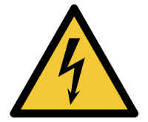  - Electrical Hazard |  | 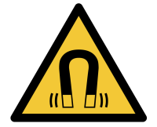  - Warning: Magnetic Field
  - Wear Eye Protection |  |   - Wear Protective Gloves

Figure 1: Applicable warning/hazard symbols

General Laboratory Safety

The following general laboratory safety instructions are applicable:

- No afterhours testing may be performed without the necessary permissions.
- Full supervised training is required before testing may be undertaken. Permission to proceed with unsupervised testing should be signed off by the lab engineer.
- Closed shoes must be worn at all times.
- Emergency equipment must be located and easily accessible.
- Students may not work alone in the laboratory.
- Emergency exits must be known. The nearest exits applicable to the setup are provided in Appendix A of this document [highlight on appropriate map selected and cropped from Appendix C of the Safety Report Guidelines]
- Loose clothing may not be worn. Loose hair must be tied up.
- Good housekeeping practices should be maintained during testing. The lab should be completely clean, including all equipment stored away, after testing. Refer to the General Housekeeping section for particulars regarding practices to be followed for this specific setup.
- No food or drink is permitted in the laboratory.
- Safety report must be visible and accessible during testing.
- No equipment or test may be left unattended.

Anticipated Interactions with other Laboratory Users

Interactions between this setup and other laboratory users will be minimised as far as possible. Surrounding users will be warned of possible hazards by the warning signs.

To ensure the integrity of the experiment while unattended, a “Do No Touch / Experiment in Progress”-sign will be hung in the vicinity of the physical setup. Furthermore, the Manson DC power supply and all control circuitry will be disconnected from the mains and locked in a secure cabinet or drawer when the researcher is absent to prevent unauthorized actuation of the electromagnet.

General Housekeeping

Ensure that the adjustable soldering iron is switched off, cooled down, and stored safely immediately after use. Store adhesives, flux pens, and RMS 1 spray securely, and dispose of used sandpaper and cleaning pads appropriately. Ensure the workspace is clear, clean, and no personal belongings are left behind.

Fire Safety

The primary fire and heat risks are associated with the soldering iron used during strain gauge installation and potential electrical shorts in the custom switching circuit. Combustible materials, such as the RMS 1 spray, must be kept away from the heated soldering iron. Evacuation routes have been noted in Appendix A. No earphones will be worn to ensure that any fire alarm can be heard.

Activity Based Risk Assessment
Activity | Risk | Risk Type* (P/E) | Mitigating Steps | Classification of Risk Severity
Entering the lab | Injuries to hands from gates / doors | P | Use caution when using the gates or heavy doors. | Acceptable risk
Moving around the lab | Tripping over cables or knocking equipment over | P | Do not use a cell phone when moving through the lab and be aware of your surroundings. | Acceptable risk
Manual surface prep | Minor abrasions / Dust | P | Sand carefully away from the body and wipe away dust. Wear safety glasses. | Acceptable risk
Using RMS 1 spray and adhesives | Skin irritation, inhalation | P | Ensure adequate ventilation. Avoid breathing vapours and wear gloves. | Possible risk
Soldering strain gauges | Burns to skin, fire hazard | P/E | Use a soldering iron stand. Keep flammable liquids away. Never leave iron unattended. | High risk
Testing the switching circuit | Electric shock | P | Inspect all cable insulation before turning on the power and ensure wire gauges can handle $6 A$ safely before turning on the power. Ensure the dedicated normally closed (NC) emergency stop button is within immediate reach and tested before full operation. | Substantial risk
Actuating the electromagnet | Crushing fingers / Pinch point | P | Keep hands clear of moving parts. Keep one hand hovering near the emergency stop button during actuation. | Possible risk
Operating the electromagnet | Strong magnetic field hazard / Magnetic interference | P/E | Strictly enforce an exclusion zone for individuals with pacemakers or metallic implants. Use the emergence stop immediately if unauthorised personnel enter the testing area. | Substantial risk
Applying excessive load | Damaging strain gauges | E | Verify all circuit limits before testing. Monitor data carefully. | Possible risk
*P – personal, E - equipment

Disciplinary Actions
Failure to comply with any of the aforementioned safety regulations or procedures will result in disciplinary action. Students will be issued an initial warning: after three warnings, the lab access is revoked for a month.

Appendix A: Sixth Floor Mechatronics Lab Evacuation Labs
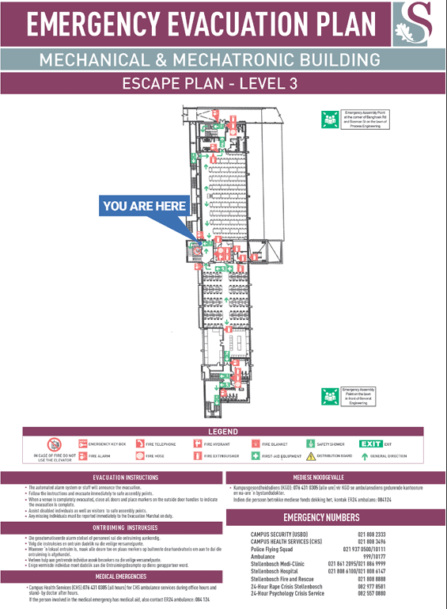

Written permission from supervisor and approved by the chief safety officer. Attach proof of this permission to this document and note here the times and conditions of the arrangement.

